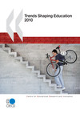
Trends Shaping Education 2010
OECD Publishing
Version: E-book (PDF Format)
Price: €17 | $24 | £15 | ¥2200 | MXN310

Imprint: Centre for Educational Research and Innovation Availability: Available Publication date: 28 Sep 2010 Language: English Pages: 90 ISBN: 9789264090040 OECD Code: 962010041E1 Frequency: Biennial Electronic format: Acrobat PDF
Other Versions & Languages | Table of contents
What does it mean for education that our societies are increasingly diverse? How is global economic power shifting towards new countries? In what ways are working patterns changing?
Trends Shaping Education 2010 brings together international evidence to address questions like these. To make the content accessible, each trend is presented on a double page, containing an introduction, two charts with brief descriptive text and a set of pertinent questions for education.
The trends presented are based on high quality international data, primarily from the OECD, the World Bank and the United Nations. The charts contain dynamic links so that readers can access the original data. Trends Shaping Education 2010 is organised around five broad themes, each with its own “find out more” section:
- the dynamics of globalisation;
- evolving social challenges;
- the changing world of work;
- transformation of childhood;
- ICT: the next generation.
This book is designed to give policy makers, researchers, educational leaders, administrators and teachers a robust, non-specialist source to inform strategic thinking and stimulate reflection on the challenges facing education, whether in schools, universities or programmes for older adults. It will also be of interest to students and the wider public, including parents.
Other languages: French (Available)
Other Versions: Print - Paperback
Further reading:
PISA 2009 Results: Overcoming Social Background - Equity in Learning Opportunities and Outcomes (Volume II) (Available)
PISA 2009 Results: What Students Know and Can Do - Student Performance in Reading, Mathematics and Science (Volume I) (Available)
PISA 2009 Results: Learning Trends - Changes in Student Performance Since 2000 (Volume V) (Available)
Education at a Glance 2010 - OECD Indicators (Available)
Education Today 2010 - The OECD Perspective (Available)
PISA 2009 Results: Learning to Learn - Student Engagement, Strategies and Practices (Volume III) (Available)
PISA 2009 Results: What Makes a School Successful? - Resources, Policies and Practices (Volume IV) (Available)
Table of contents:
Introduction
-What can be found in this publication?
-For whom is this tool relevant?
-Trends shaping education
-How to use this resource
1. The dynamics of globalisation
-Our crowded planet
-Populations on the move
-Global environmental challenges
-International divides of affluence and poverty
-Towards a global economy
-New global economic powers
-Find out more
2. New social challenges
-Changing age structures
-Changing patterns of social expenditure
-Inequality on the rise
-The persistence of poverty
-New forms of community engagement
-More satisfied with life
-Find out more
3. The changing world of work
-Changing life cycle patterns
-More flexibility in the labour market?
-Knowledge-intensive economies
-Massification and globalisation of higher education
-Women in the labour market
-Find out more
4. Transformation of childhood
-Living in more diverse families
-Smaller families, older parents
-Children’s health
-Children’s inheritance of life chances
-Expecting more of children
-Find out more
5. ICT: The next generation
-Towards universal access
-Where do students use computers?
-The evolving World Wide Web
-Rapidly growing participation online
-The world in your pocket
-Find out more

Trends Shaping Education 2010
Send Print
Introduction | Table of contents
How to obtain this publication | Website
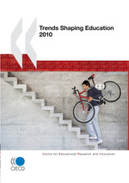  ISBN: 9789264075269  Publication: 28/9/2010 |  | Trends Shaping Education 2010  What does it mean for education that our societies are increasingly diverse? How is global economic power shifting towards new countries? In what ways are working patterns changing?  Trends Shaping Education 2010 brings together international evidence to address questions like these. To make the content accessible, each trend is presented on a double page, containing an introduction, two charts with brief descriptive text and a set of pertinent questions for education.  The trends presented are based on high quality international data, primarily from the OECD, the World Bank and the United Nations. The charts contain dynamic links so that readers can access the original data. Trends Shaping Education 2010 is organised around five broad themes, each with its own “find out more” section:  - the dynamics of globalisation;  - evolving social challenges;  - the changing world of work;  - transformation of childhood;  - ICT: the next generation.  This book is designed to give policy makers, researchers, educational leaders, administrators and teachers a robust, non-specialist source to inform strategic thinking and stimulate reflection on the challenges facing education, whether in schools, universities or programmes for older adults. It will also be of interest to students and the wider public, including parents.  The Excel™ spreadsheets used to create the tables and charts in this book are available via the StatLinks printed in this book.

Introduction
This book is about major developments that are affecting the future of education and setting challenges for policy makers and education providers alike. It does not give conclusive answers: it is not an analytical report nor is it a statistical compendium, and it is certainly not a statement of OECD policy on these different developments. It is instead a stimulus for thinking about major trends with the potential to influence education. While the trends are robust, the questions raised for education in this book are illustrative and suggestive. We invite users to look further and to add to this basic coverage examples of trends from their own countries or regions.
- Complete introduction

Table of contents
- Introduction.
- Chapter 1. The dynamics of globalisation
- Chapter 2. New social challenges
- Chapter 3. The changing world of work
- Chapter 4. Transformation of childhood
- Chapter 5. ICT: The next generation ....

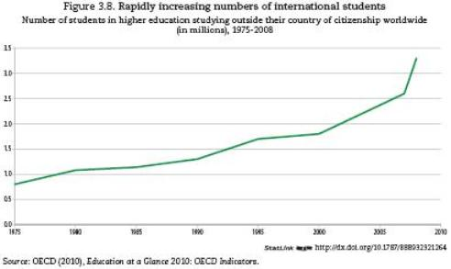

How to obtain this publication
Readers can access the full version of Trends Shaping Education 2010 choosing from the following options:
- Subscribers and readers at subscribing institutions can access the online edition via iLibrary.
- Non-subscribers can purchase the PDF e-book and/or paper copy via our Online Bookshop.
- Order from your local distributor
- Government officials with accounts (subscribe) can go to the "Books" tab on OLIS.
- Access by password for accredited journalists

Websites
- Centre for Educational Research and Innovation (CERI)
Top of page

